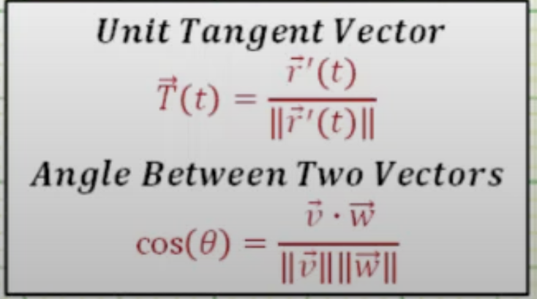

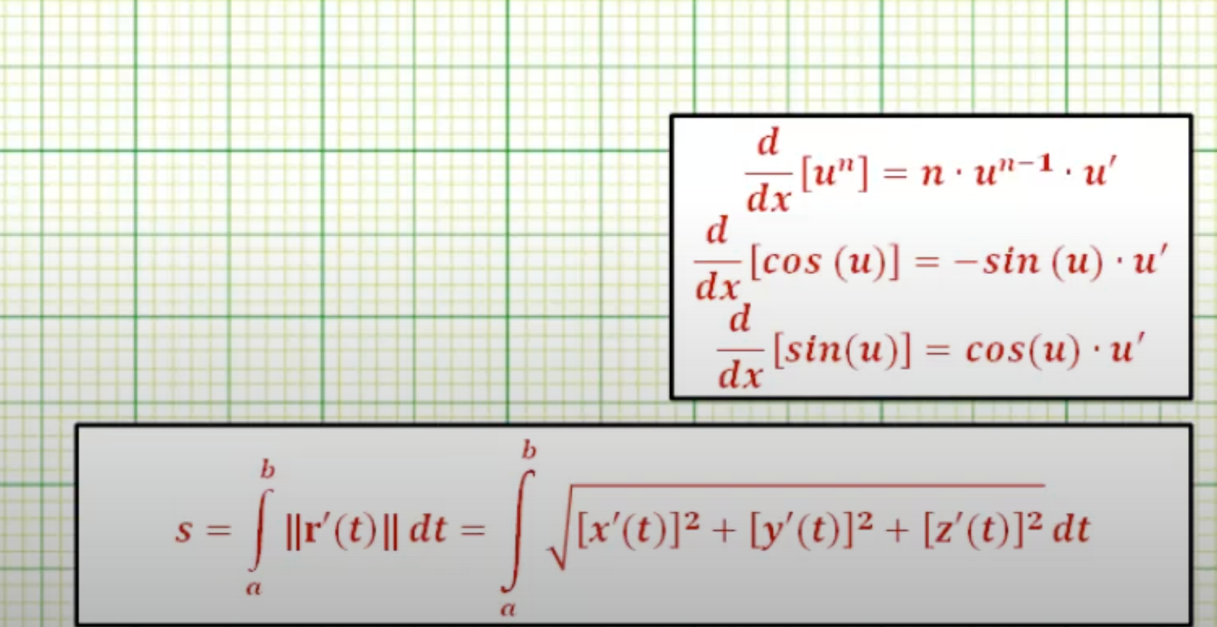

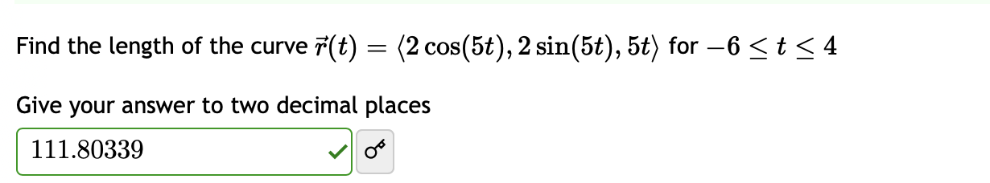

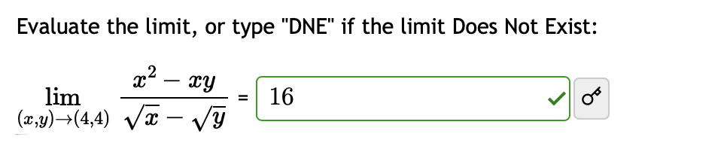

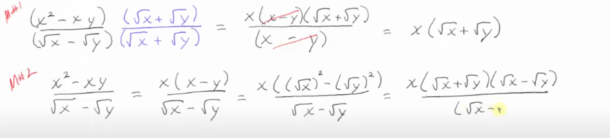

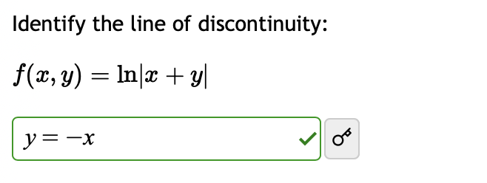

Chapter 11:

* Find formula of seri (start with n = 1)
* Find lim -> Bound/Unbound
* Monotonic/ Not monotonic
* Converge/ Diverge
* Calculate sum (Be careful with the starting value of n):
* Lim 1/k converges but Sum 1/k diverges

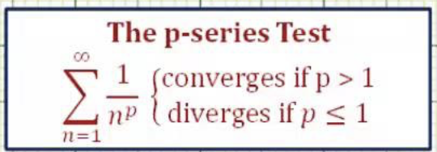

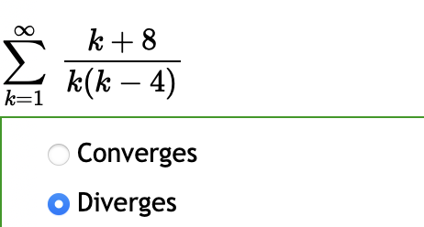

* (Start with n = 0 )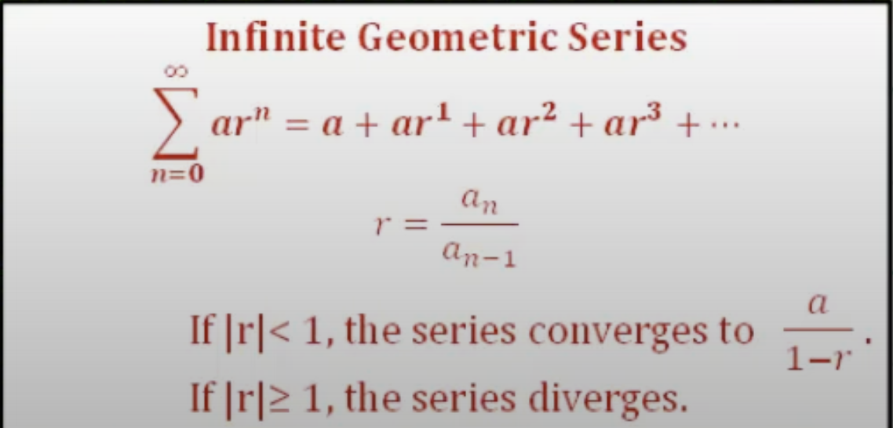

Example:

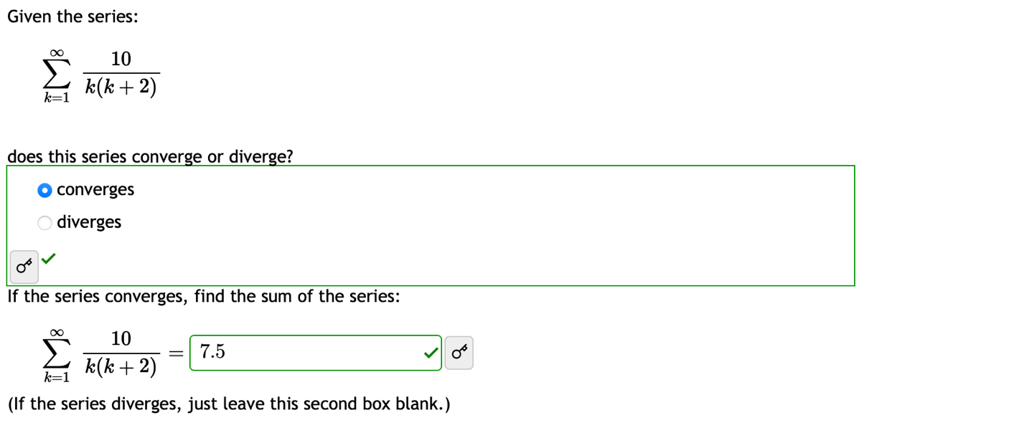

Use: 1/(k*(k+1))=A/k + B/(k+1)

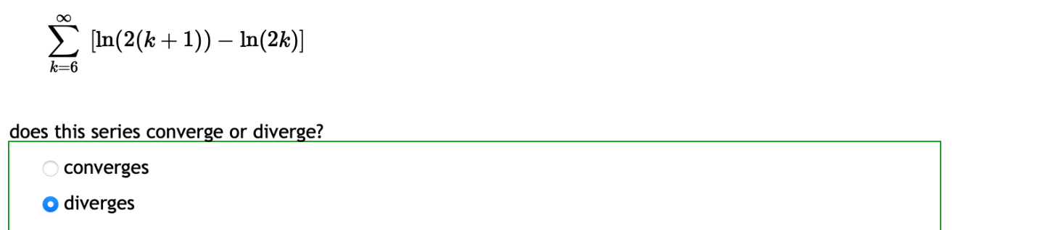

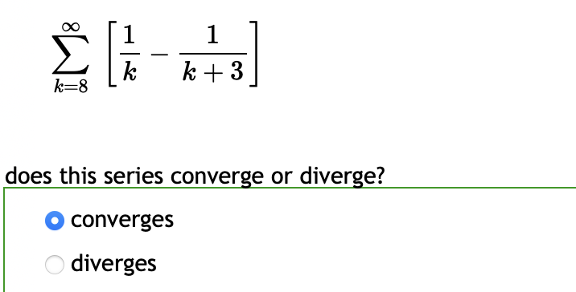

Integral – Comparation – Alternating

Integral: 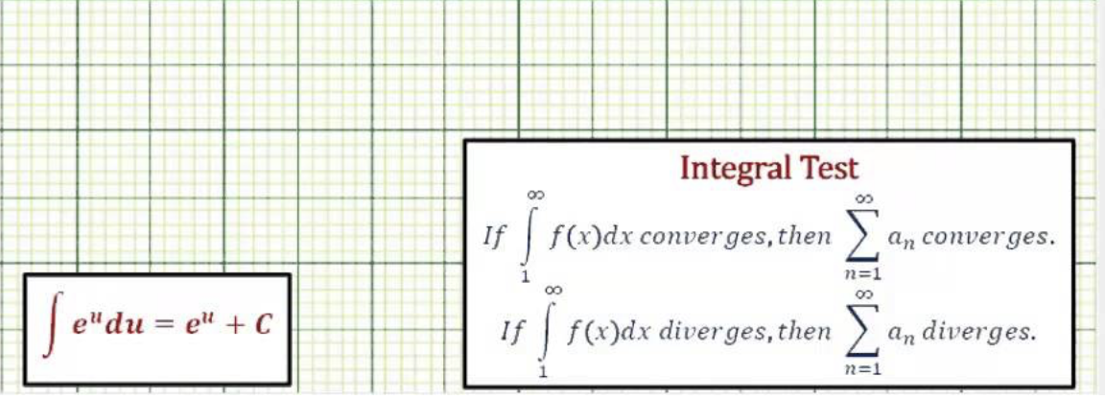

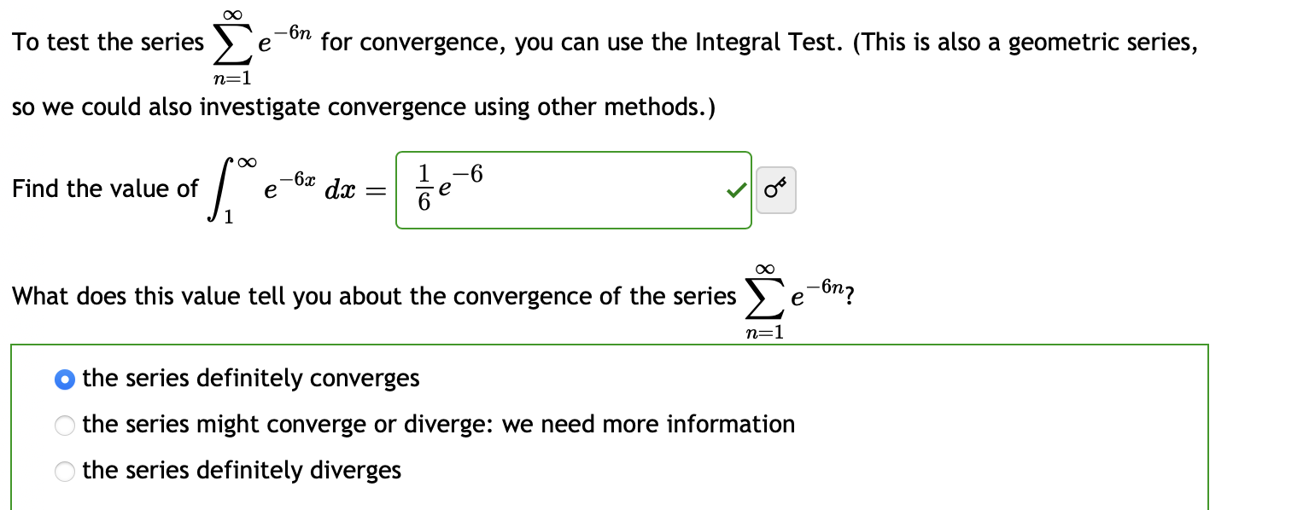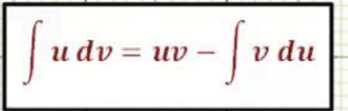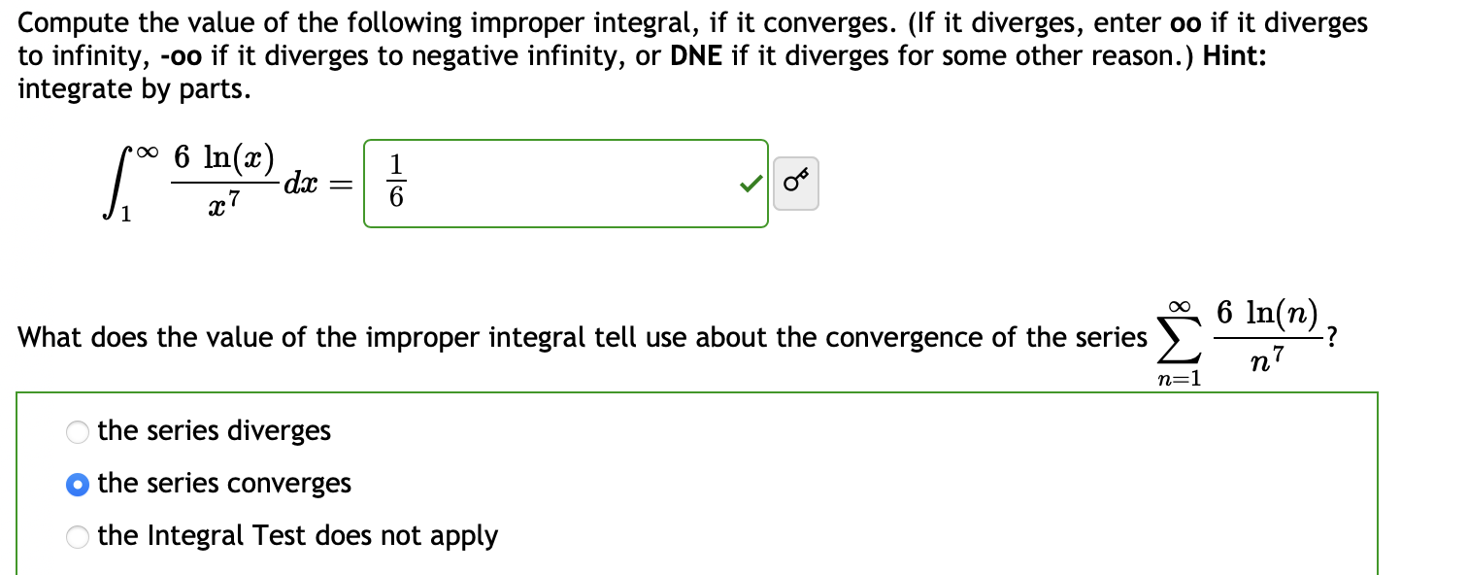

Comparasion Tests

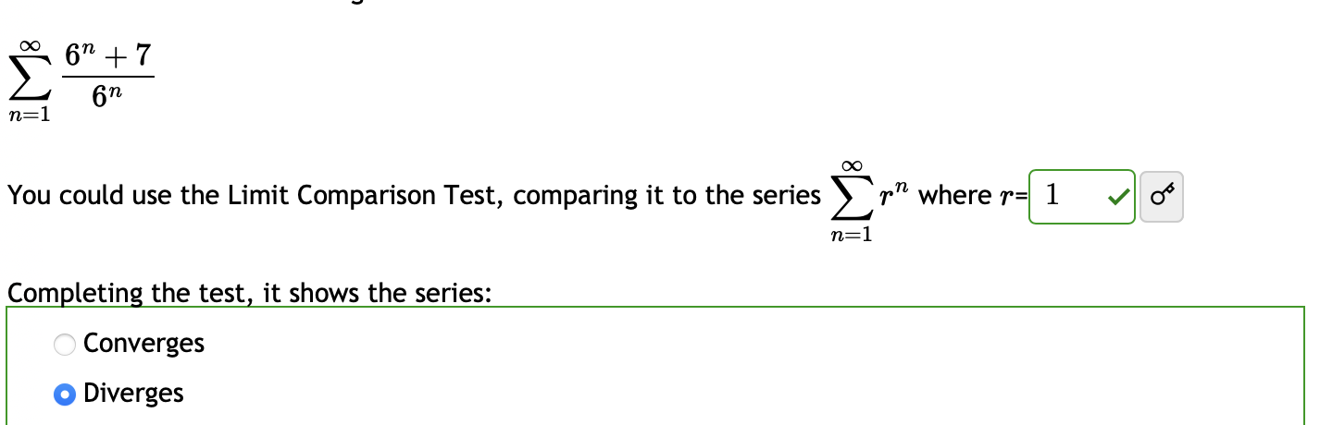

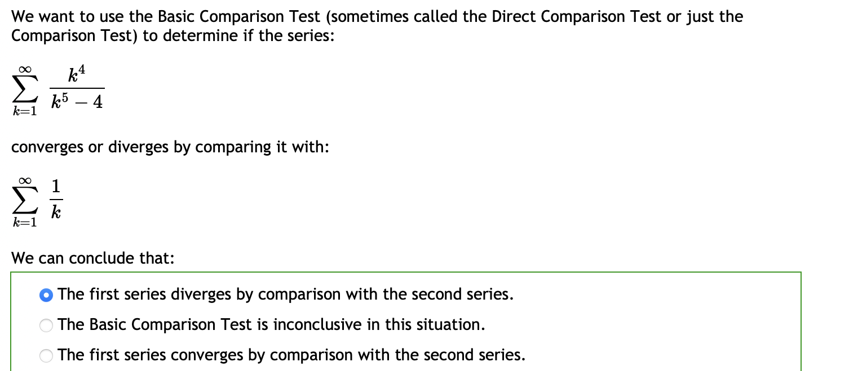

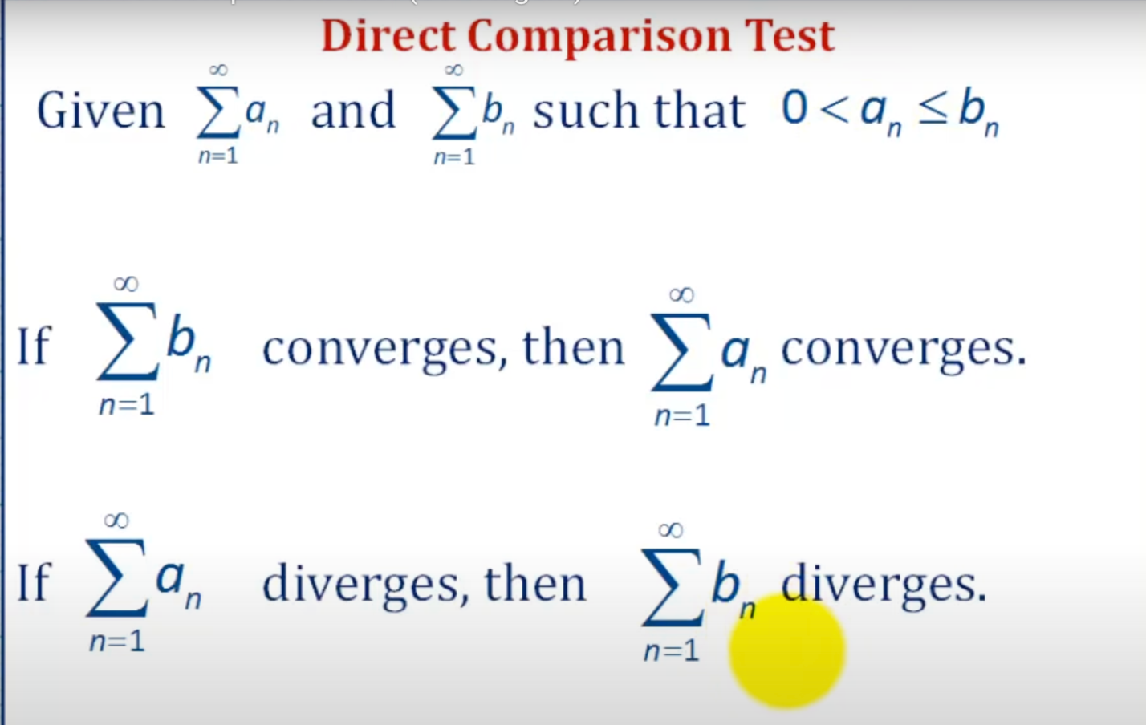

Alternating seri

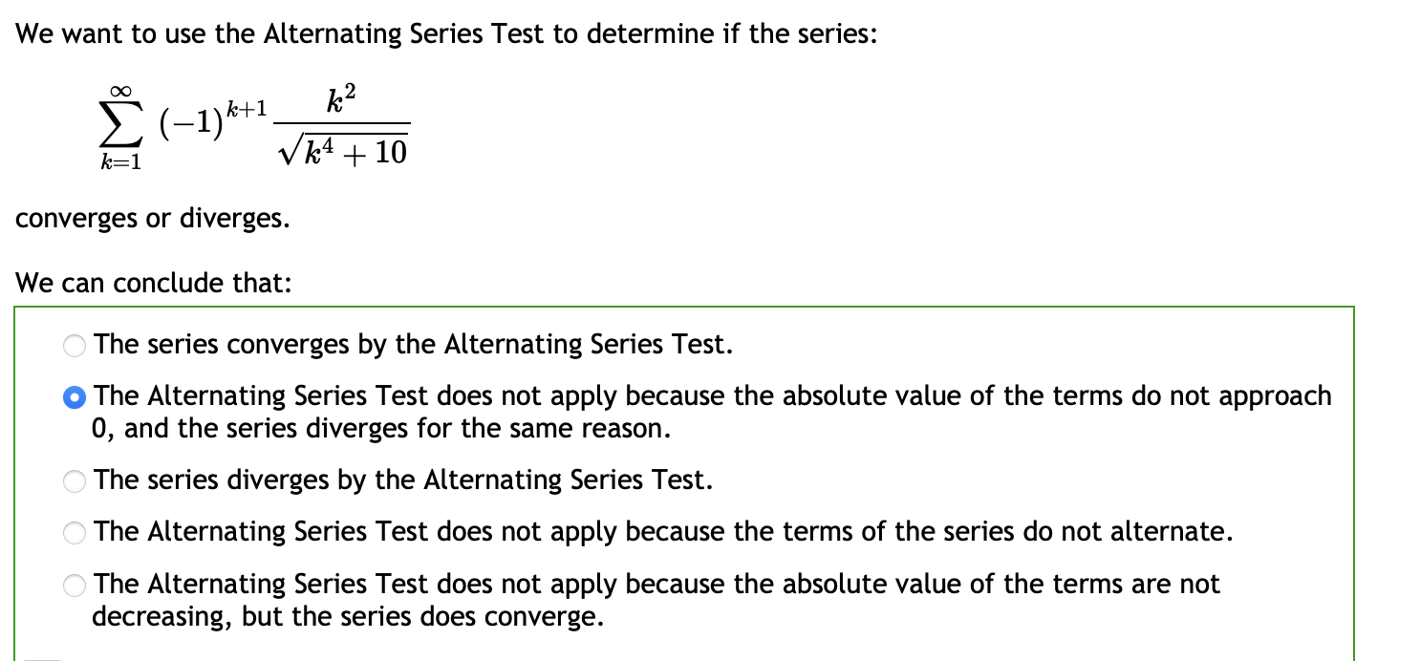

Check it is monotonic + decrease ???

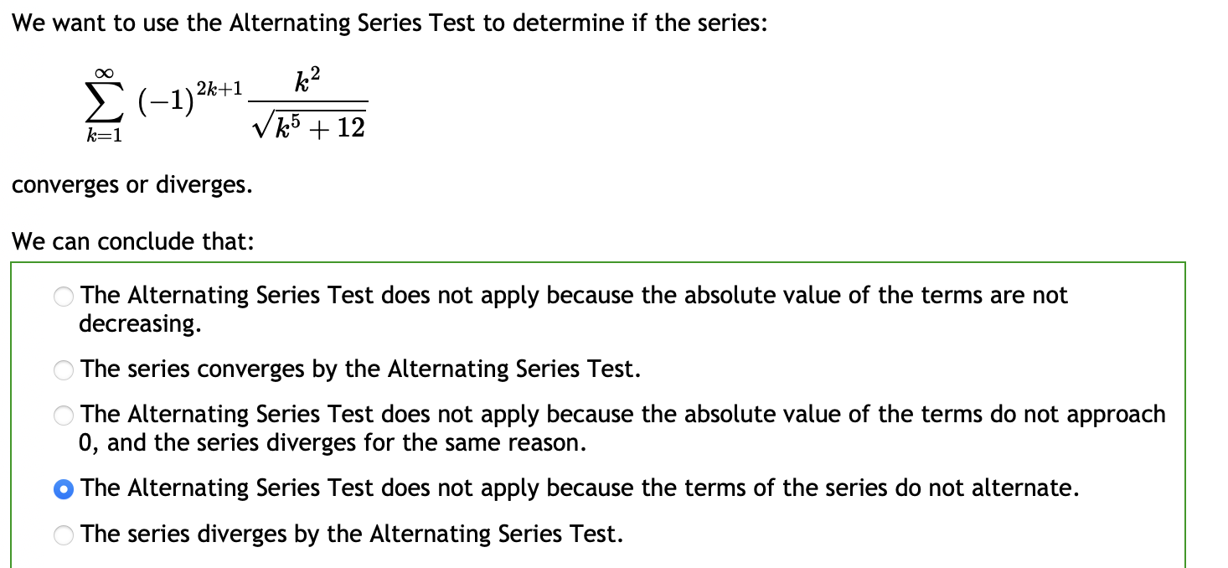

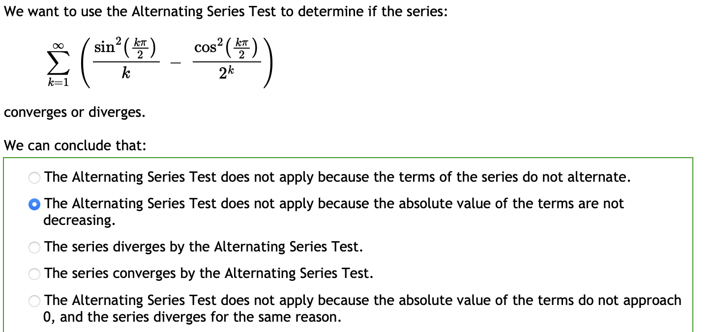

Be careful with the starting value of k

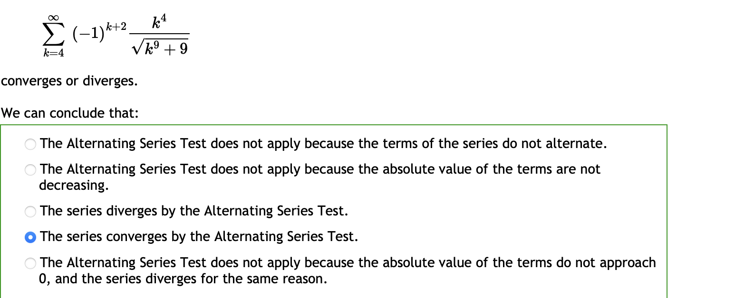

Remember it is **n+1 not n and should not use calculation to find root.**

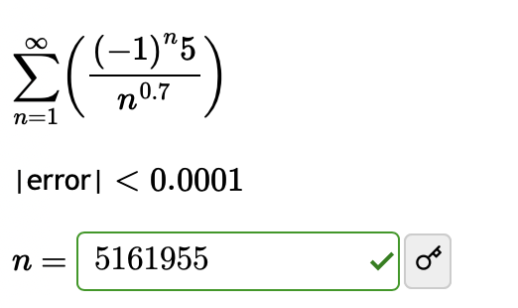

The 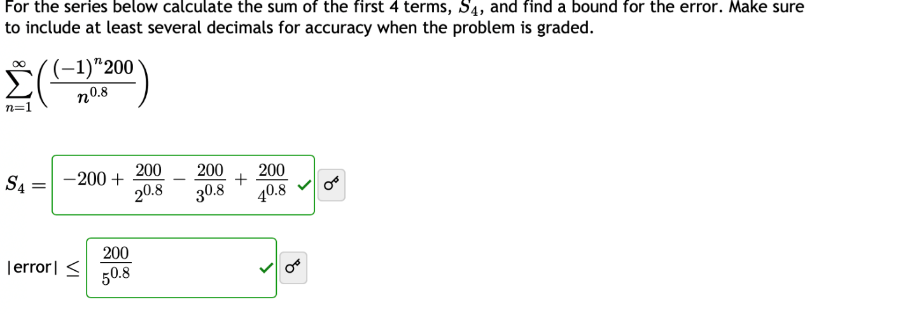

The next term

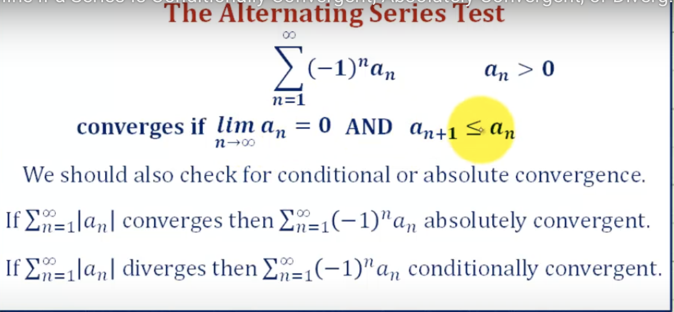

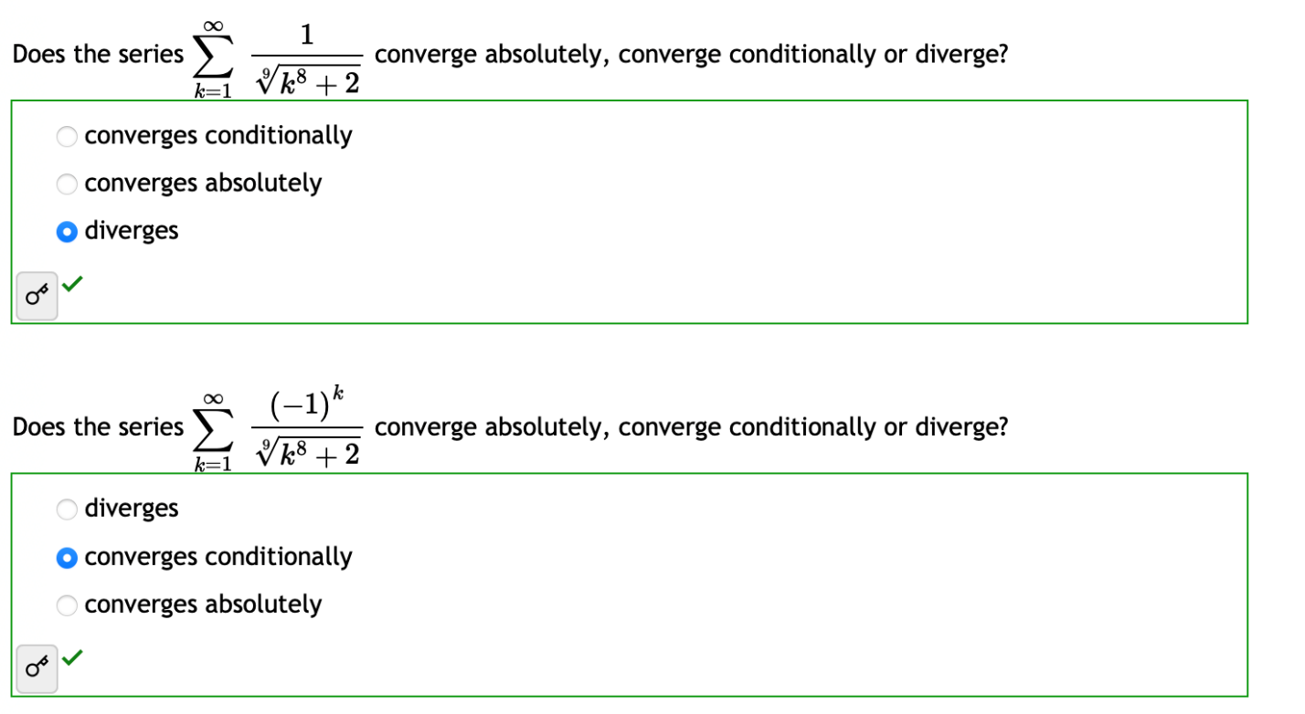

The next terms of seri always decrease -> conditionally

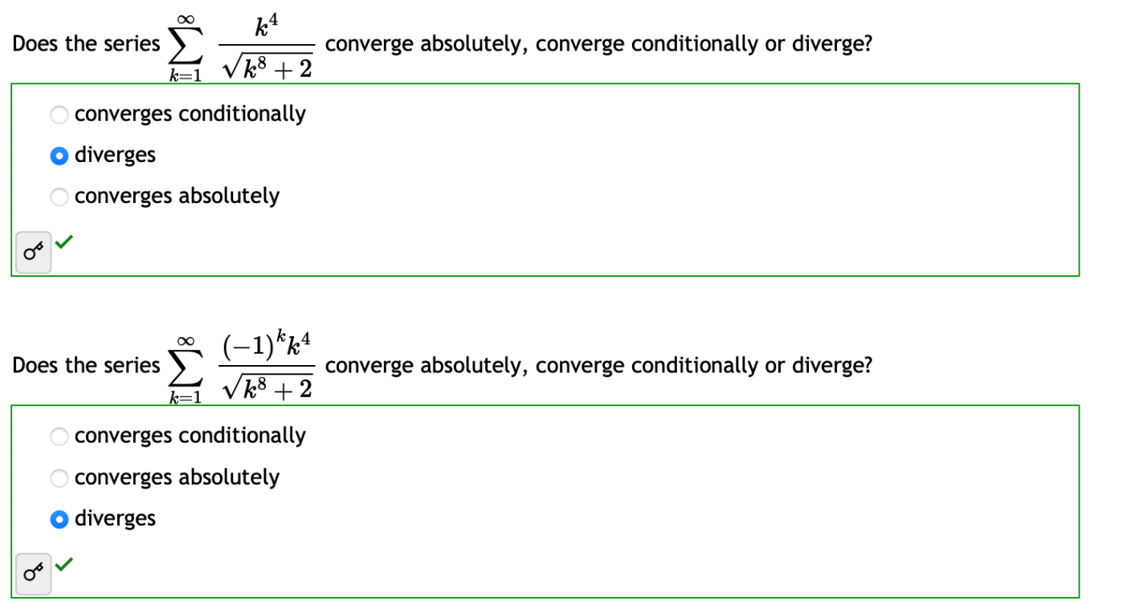

The next terms of seri always increase -> absolutely

**Ratio and Root Tests**

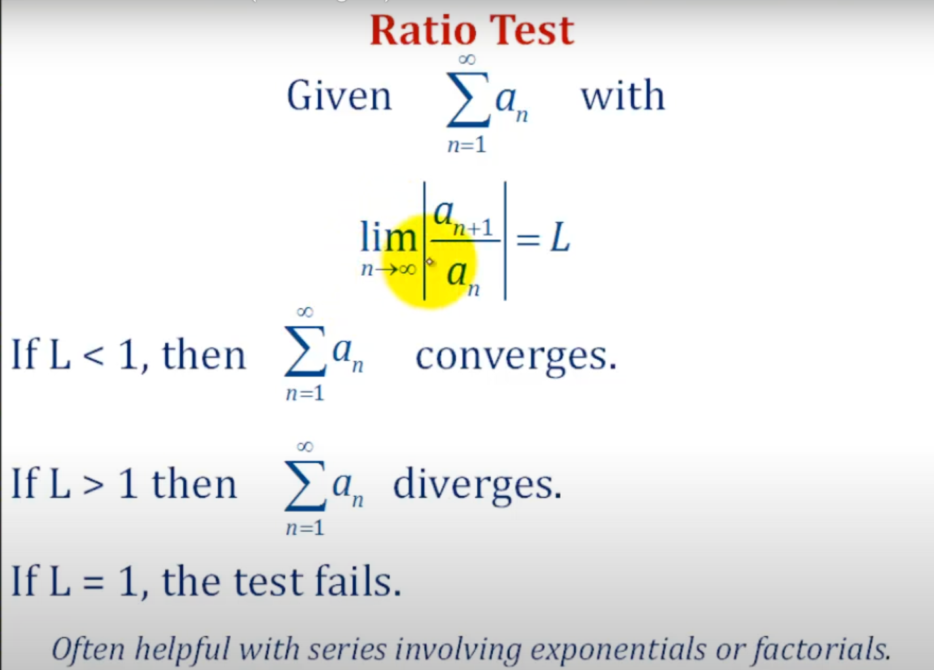

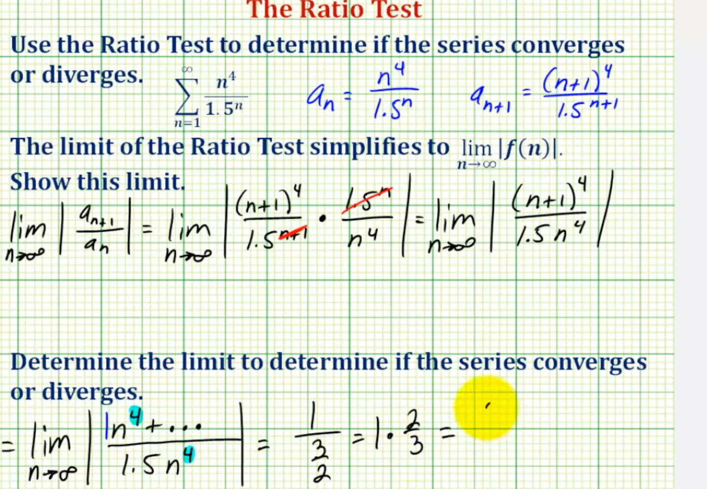

Exercise:

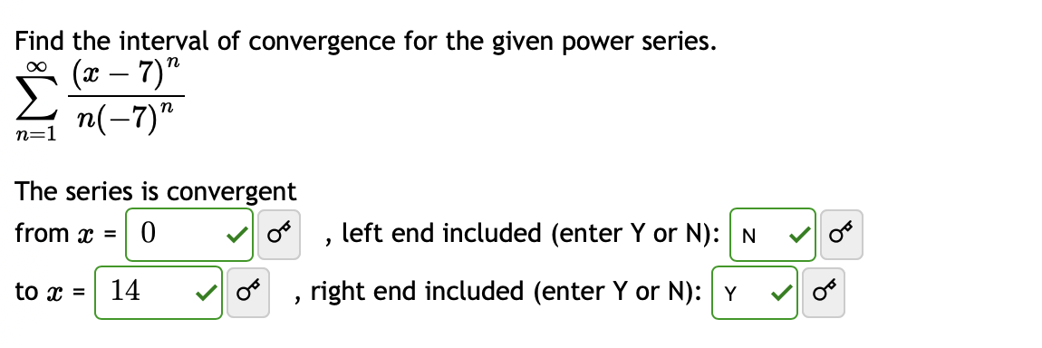

Sum(1/n) -> diverges

Sum((-1)^n))*1/n -> converges

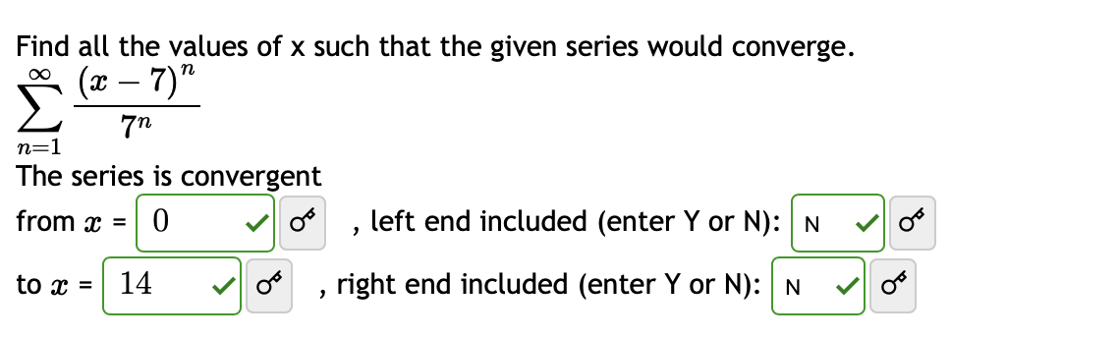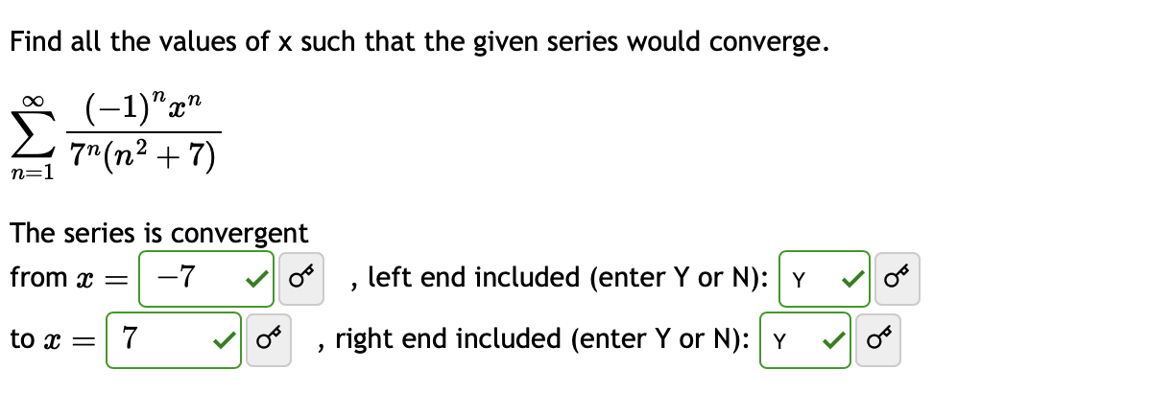

# Taylor and Maclaurin Series



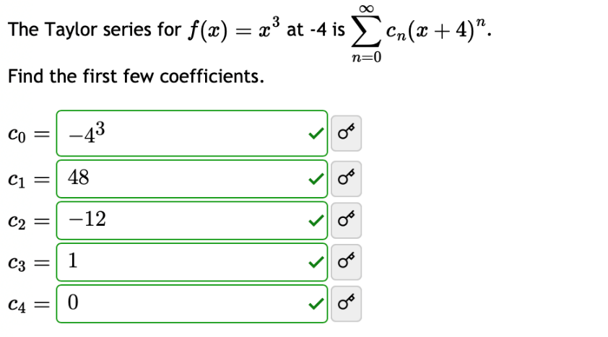

Cn = fn(x0)/(n!)

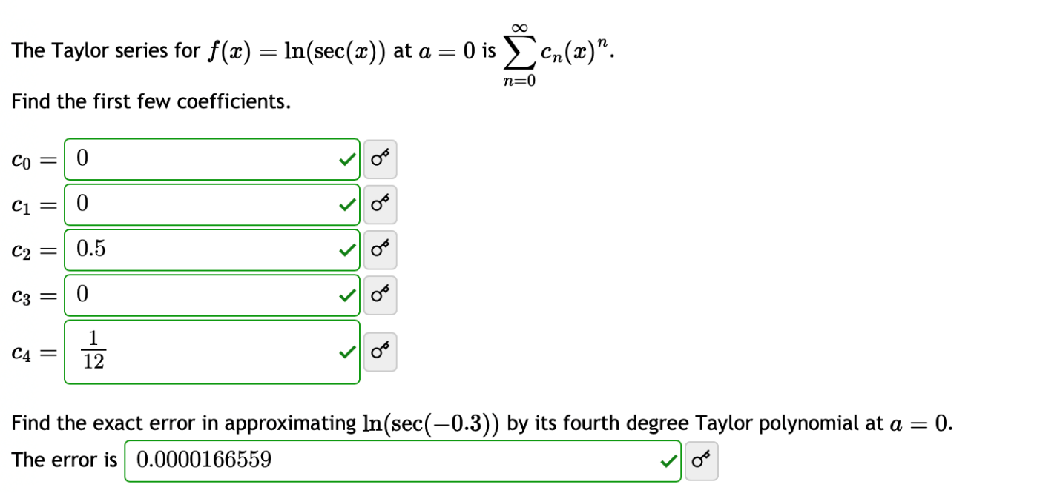

* Copy this Exercise (formula)

Remember this question

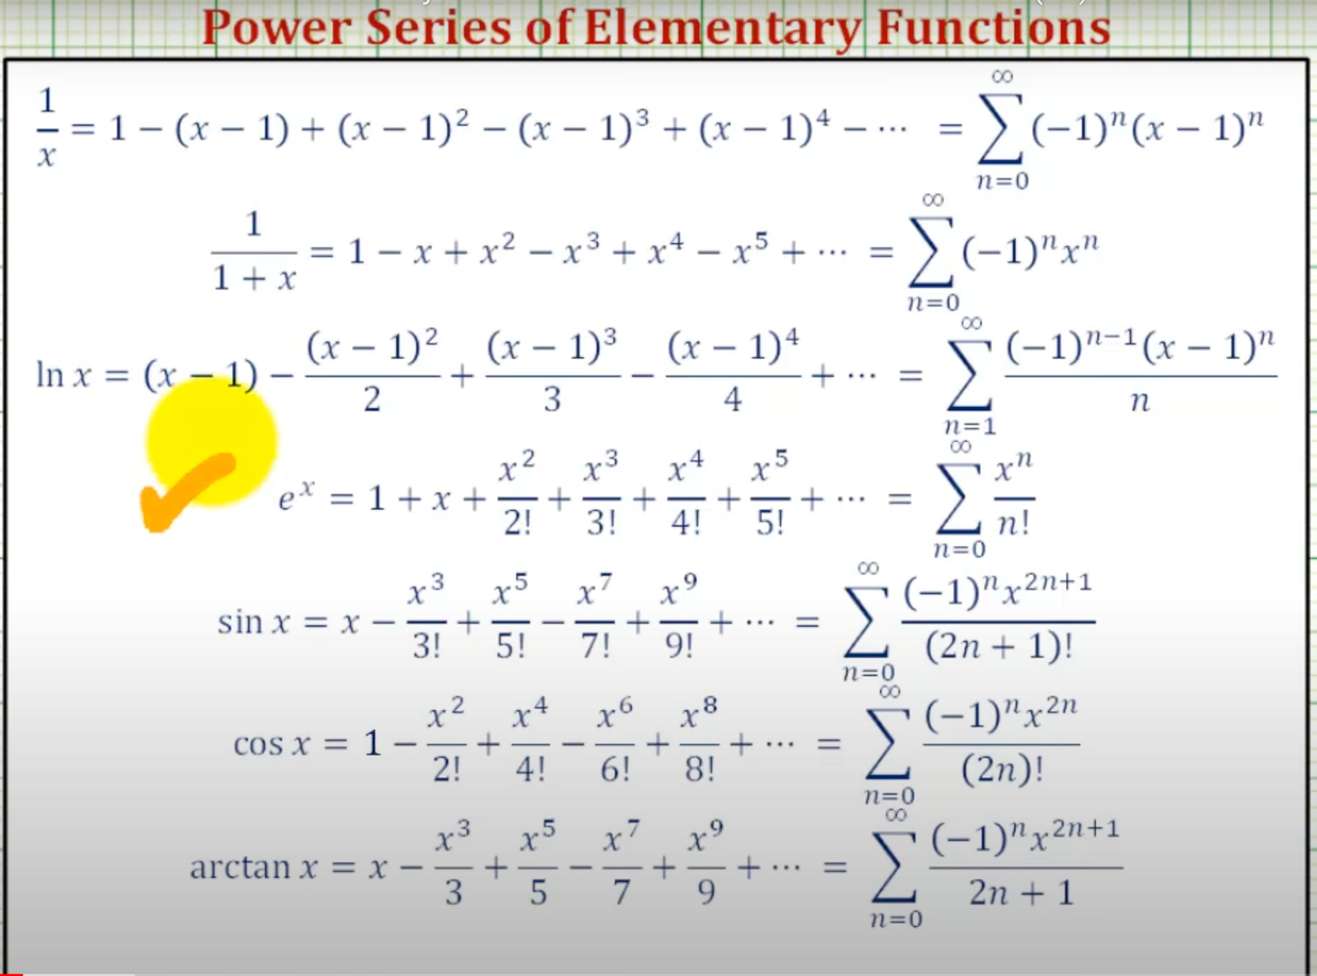

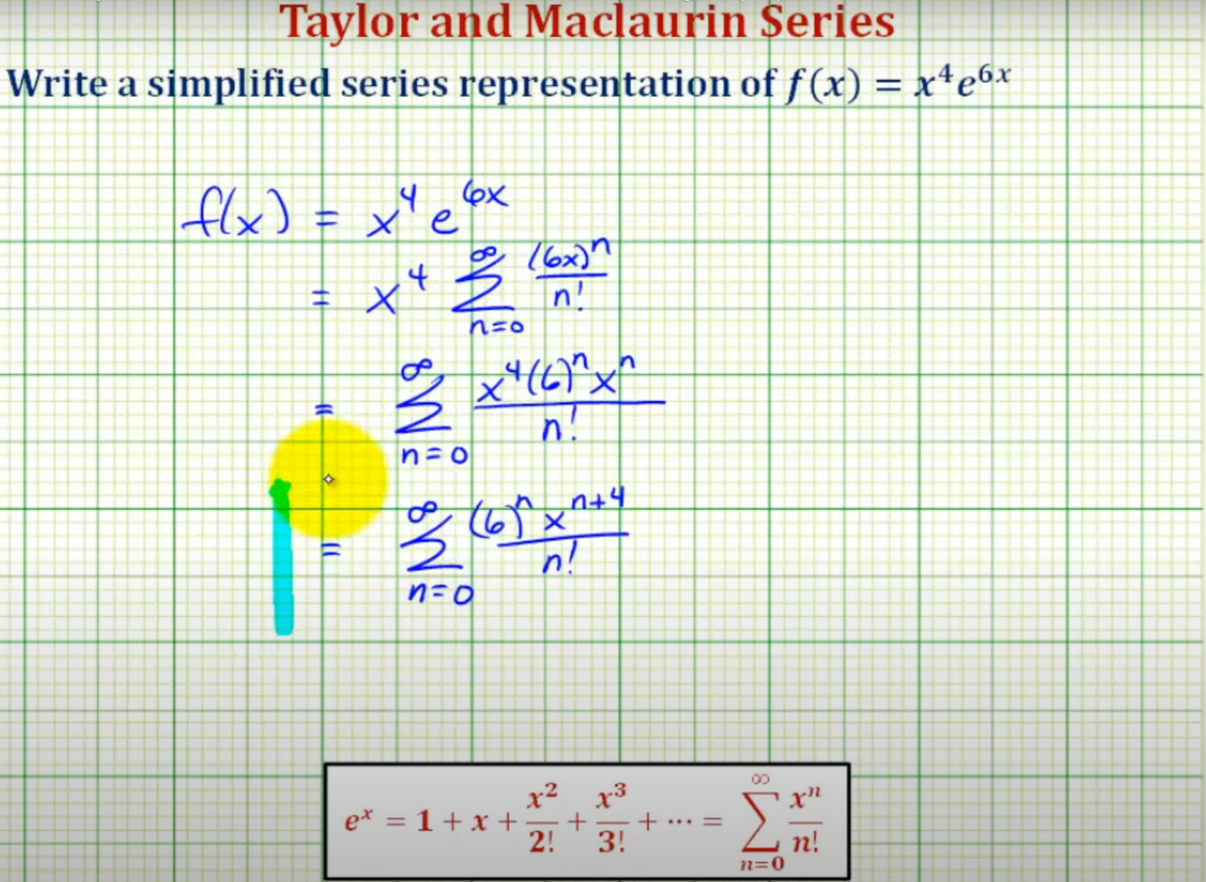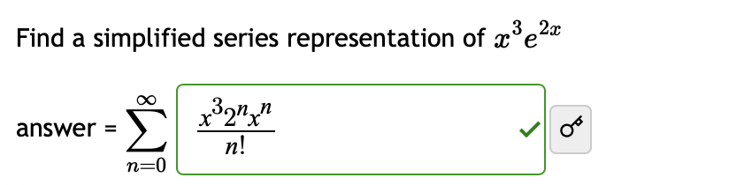

# Vectors in the Plane

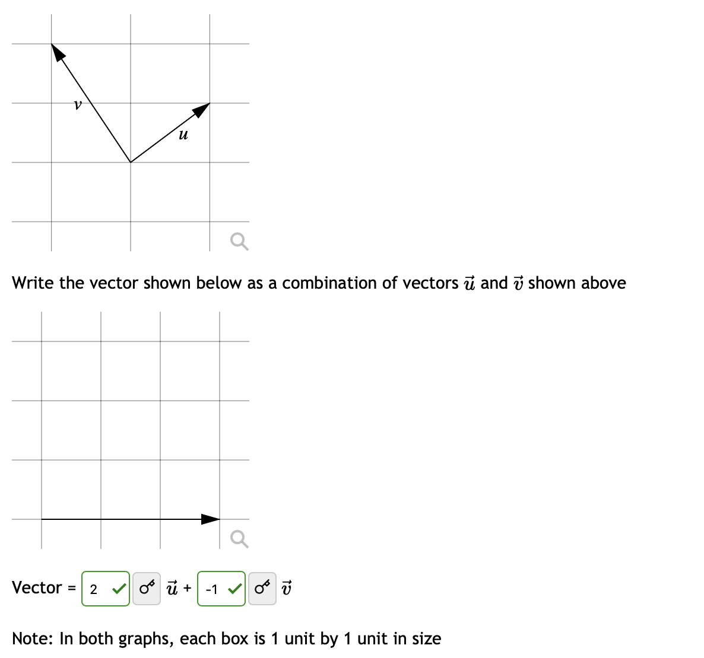

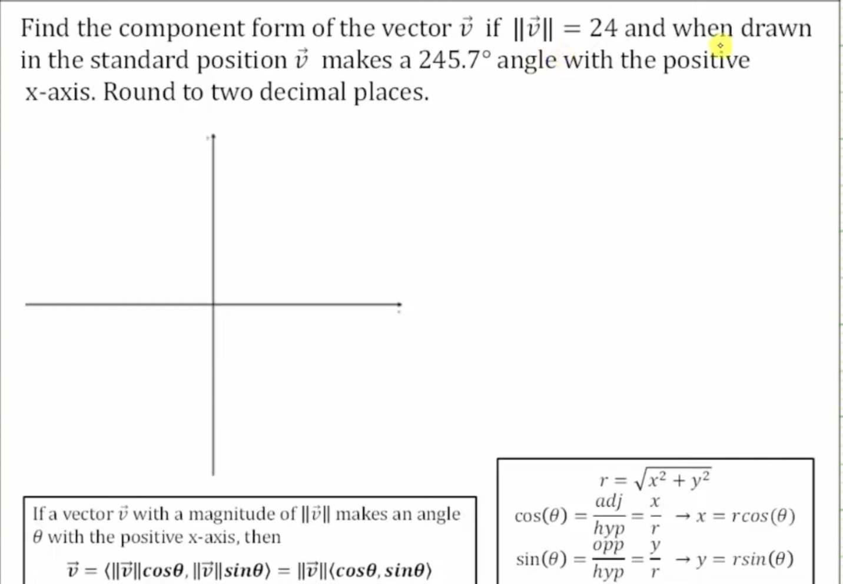

I = magnitude x cos()

J = magnitude x sin()

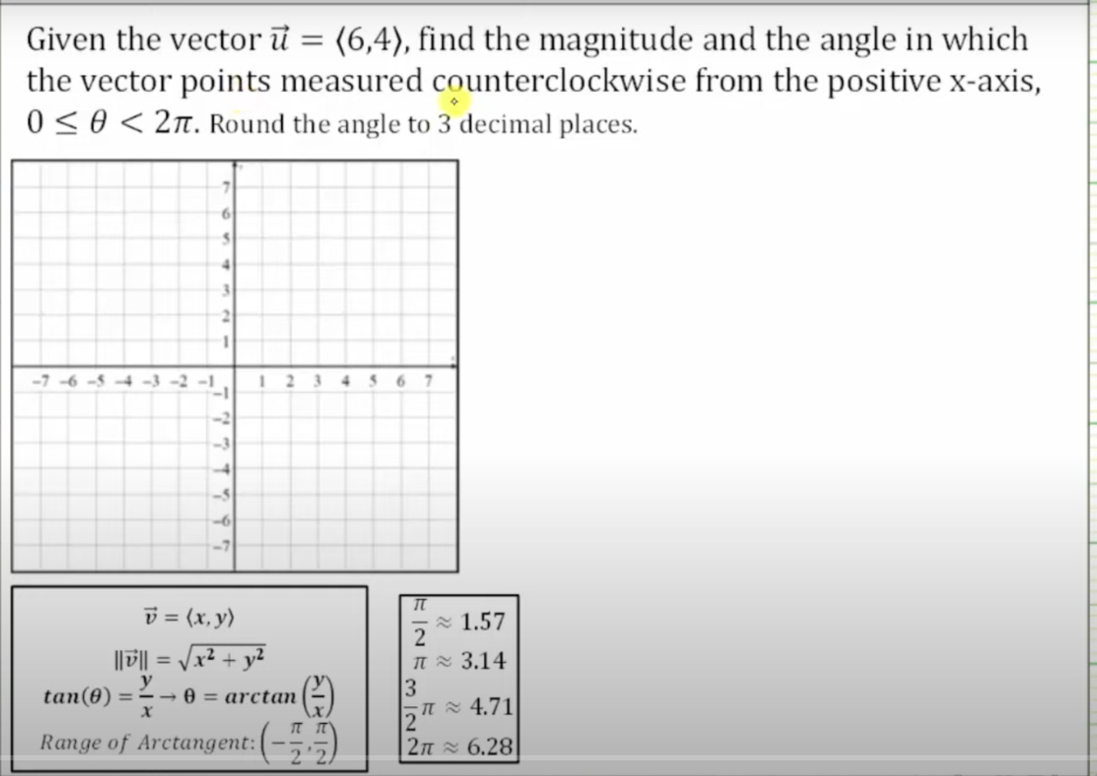

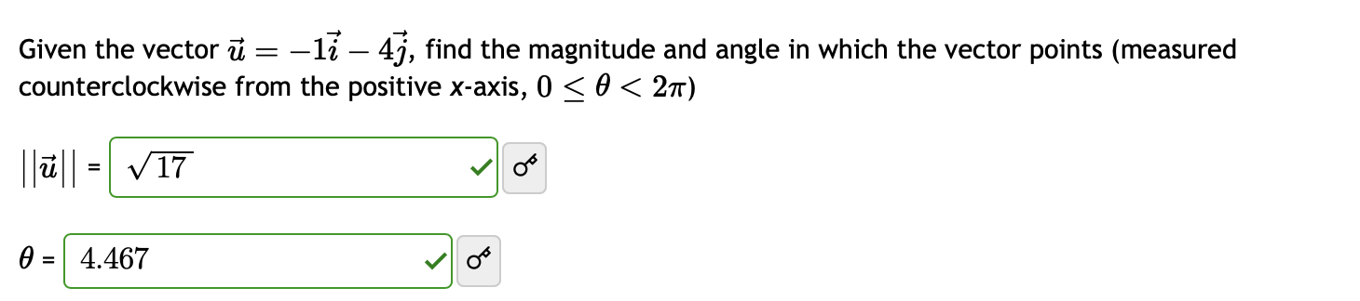

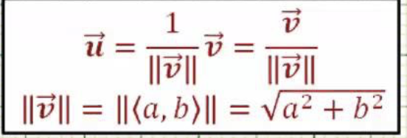

Unit vector:

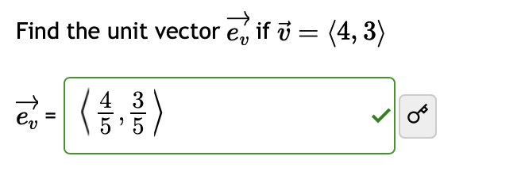

# Vectors in Three Dimensions

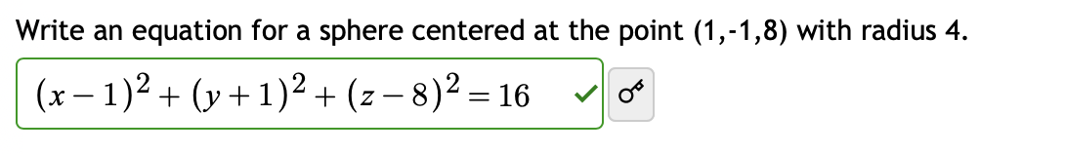

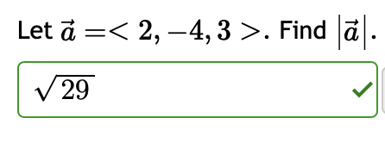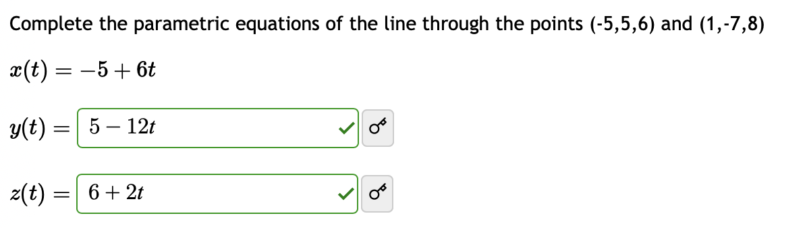

Calculate vector -> fill point

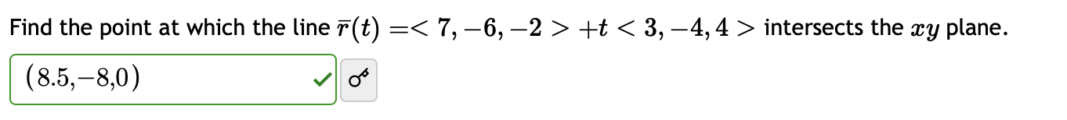

Find t -> point

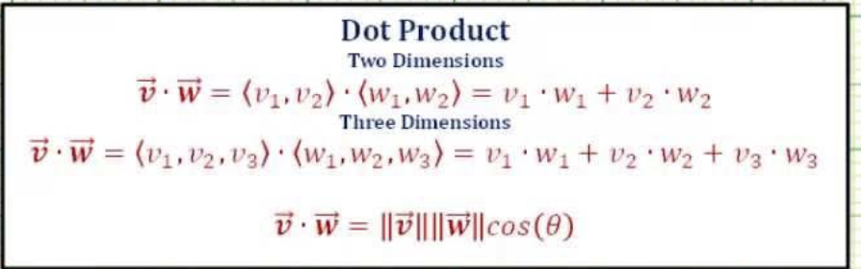

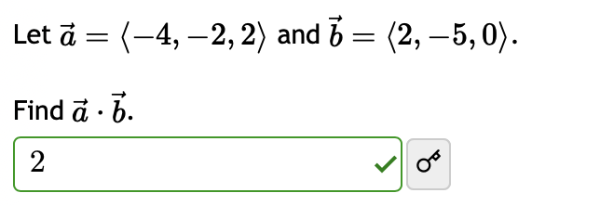

MODE 5 -> 1 (define vector A) -> choose dimension (2 or 3) -> fill -> AC -> OPTN -> 1 (choose define vector) -> choose 1/2/3/4 to choose vector defined -> fill

OPTN 3/4/5/6 (choose 2 vector to calculate)

* DOT: OPTN -> DOWN -> 2
* CROSS : x

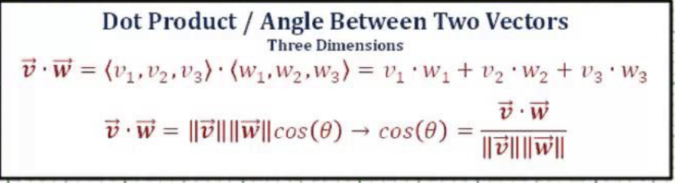

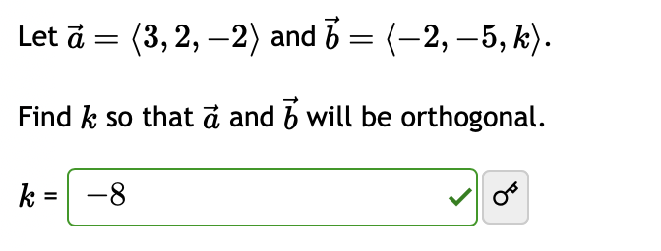

DOT(VECTOR A, VECTOR B)= 0

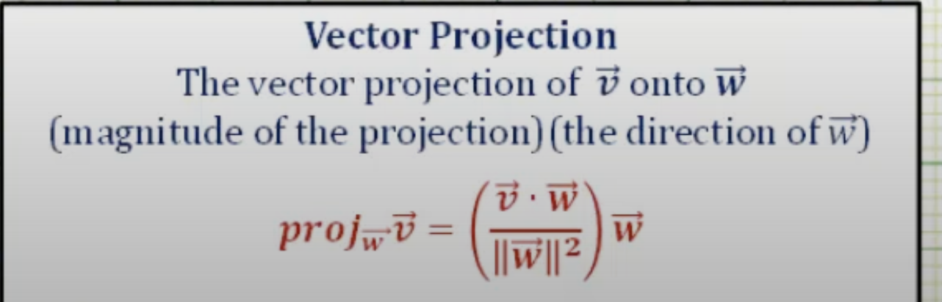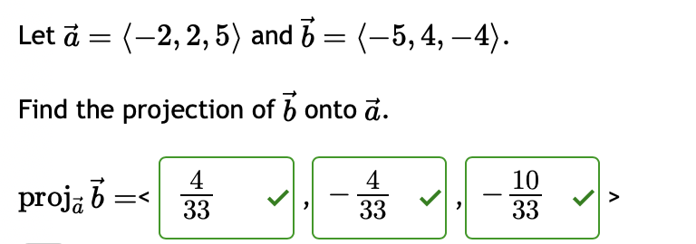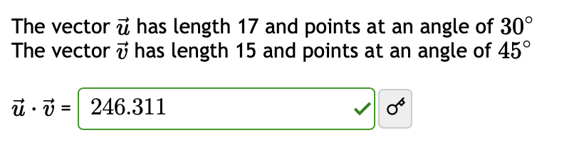

# The Cross Product

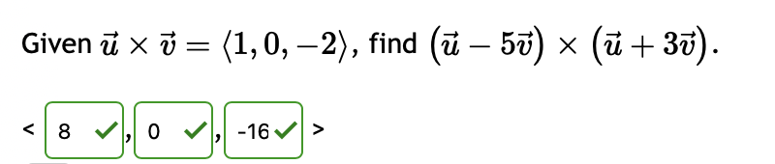

Vector(u) x Vector(u) = 0

Vector(u) x Vector(v) = - Vector(v) x Vector(u)

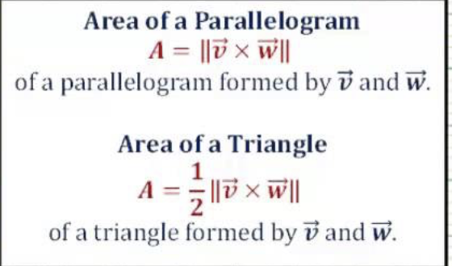

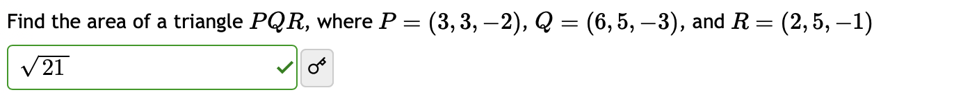

* Remember the same orgin

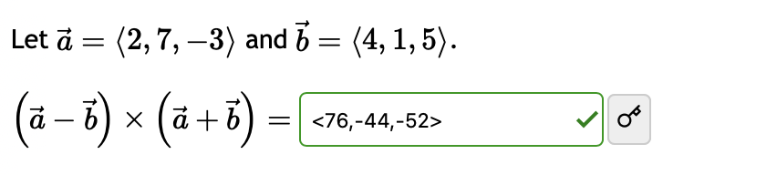

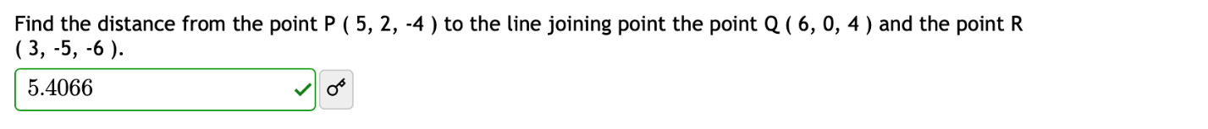

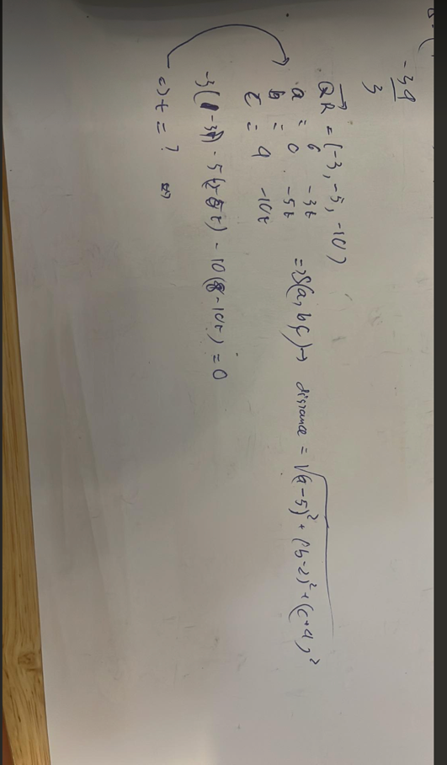

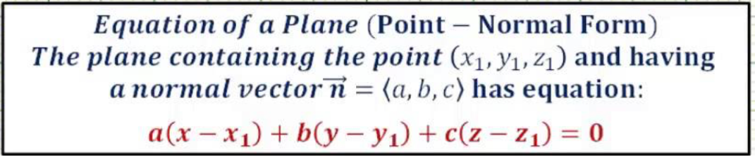

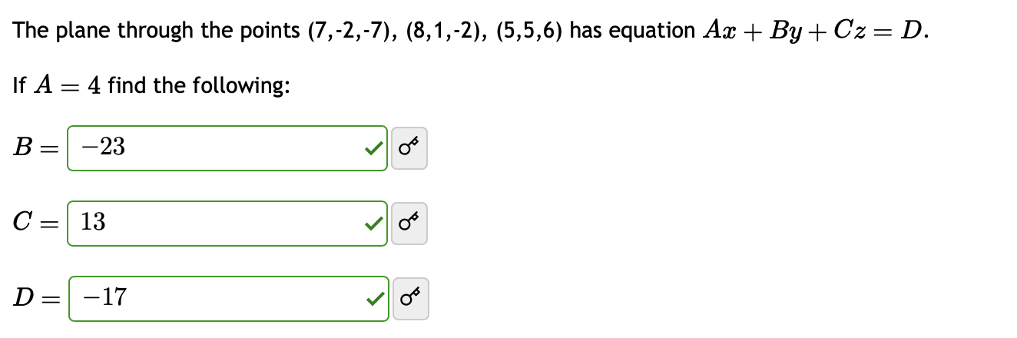

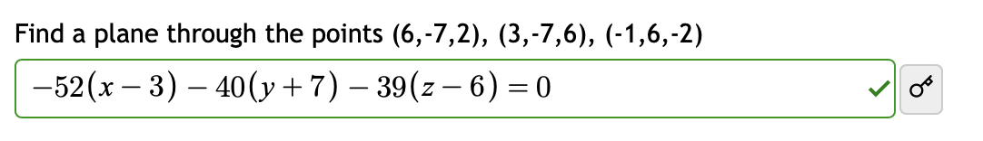

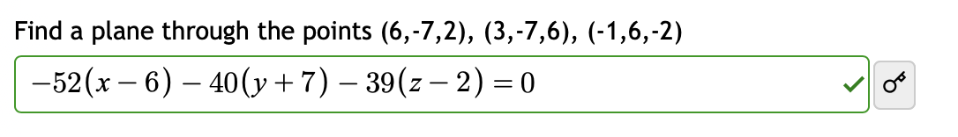

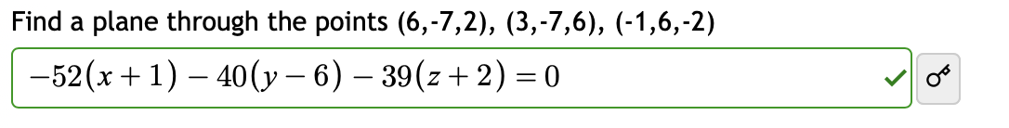

Find cross of 2 vectors (the same origin) -> apply the formula (any point)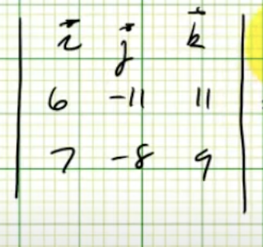

Formula of cross:

Exercise:

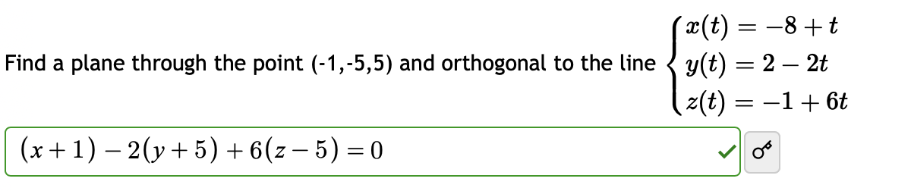

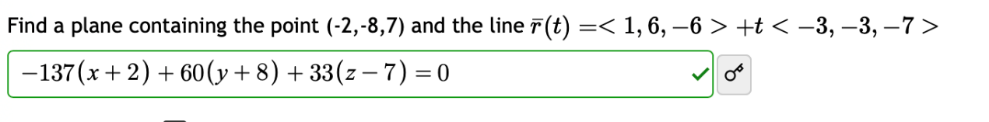

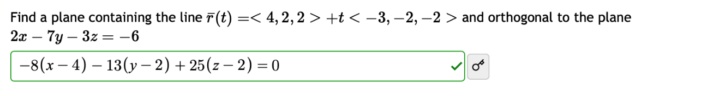

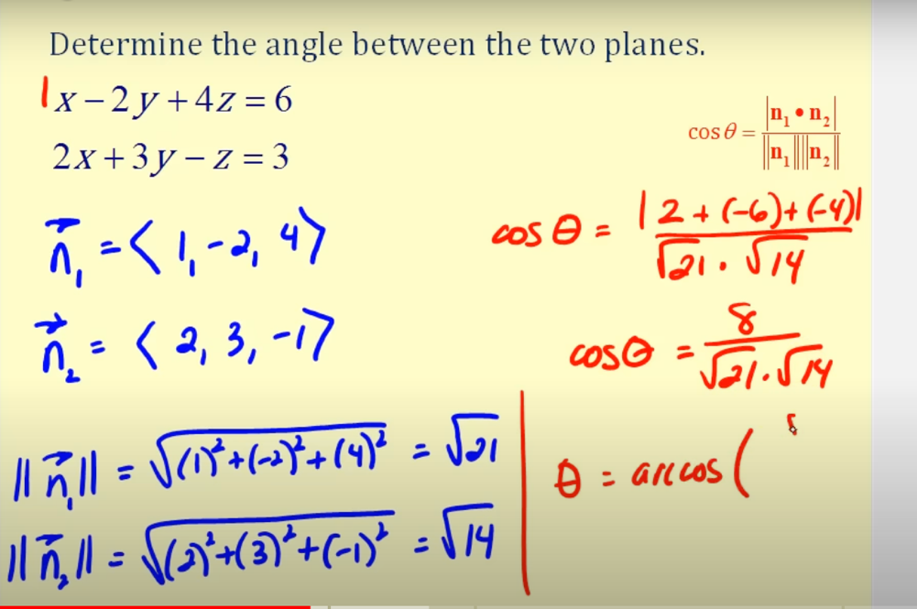



Arcos((-2*2+0*-2-3*-4)/(sqrt(2^2+4^2)*(sqrt(2^2+(-2)^2+(-3)^2))))

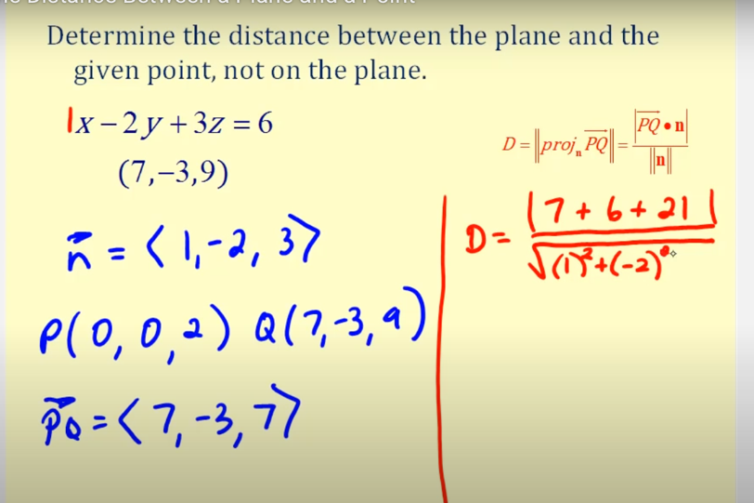

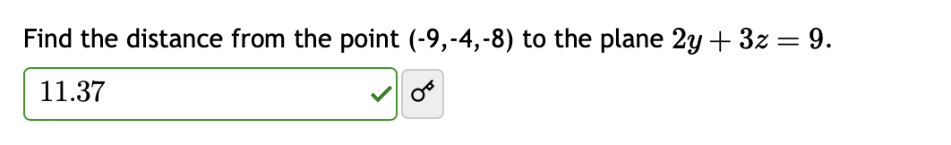

Find point(a,b,c) -> calculate vector -> incorporating with the given vector (2 vector) -> calculate distance (in this case: given vector is n)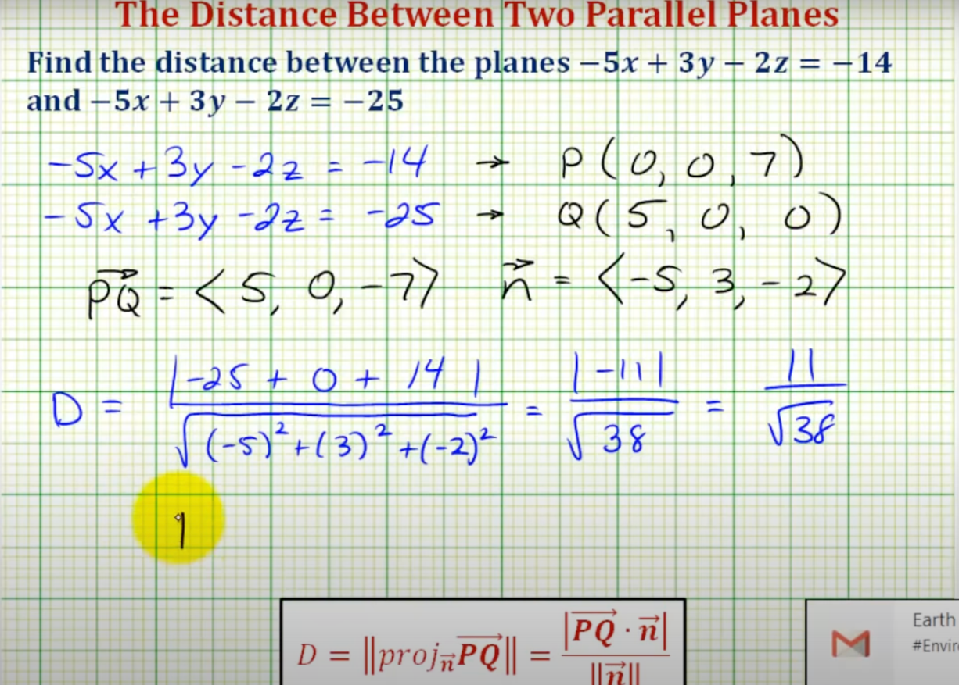

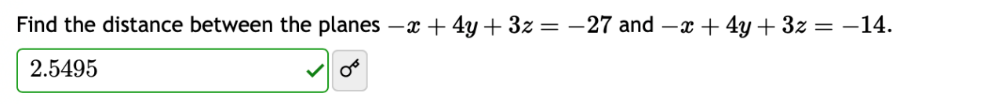

# Quadric Sufaces

# Vector-Valued Functions and Space Curves

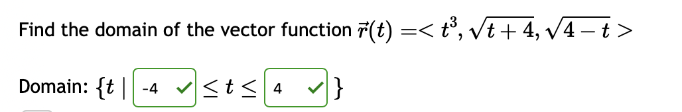

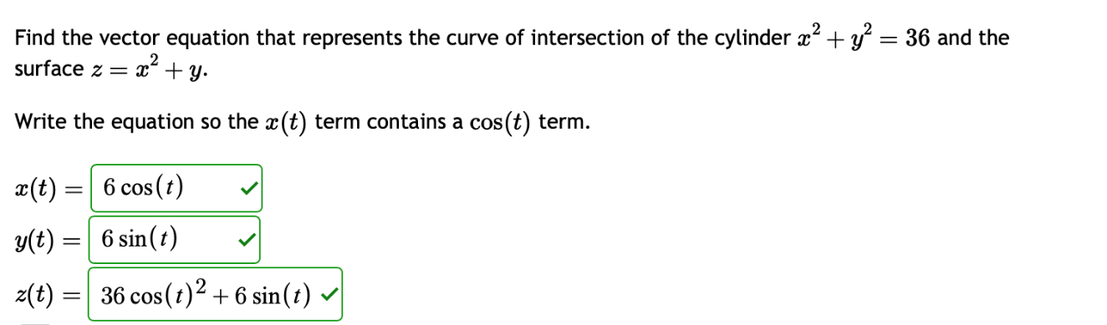

X -> sin

Y -> cos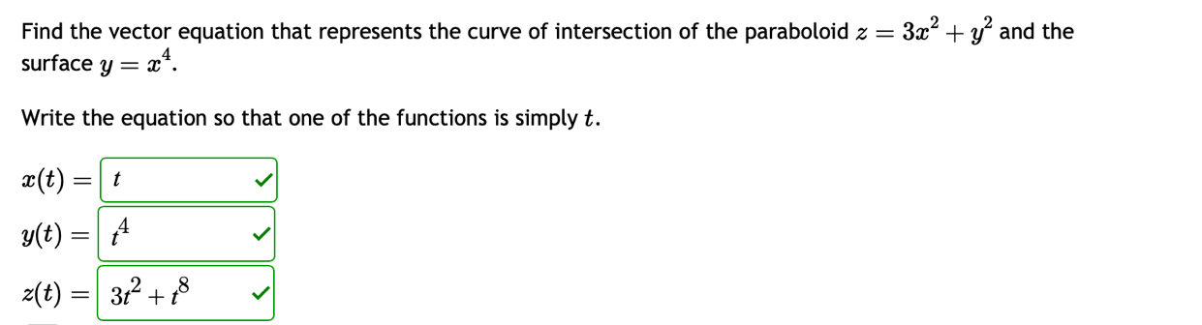

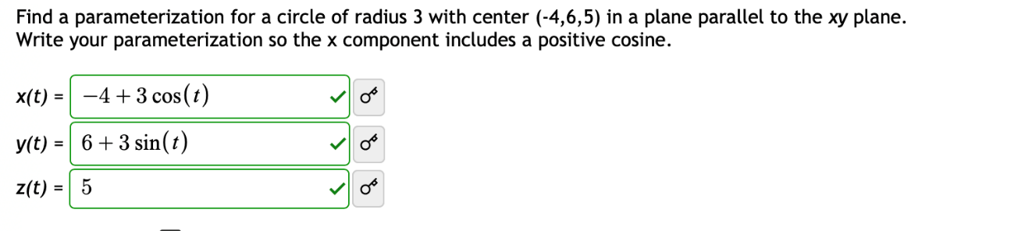

# Calculus of Vector-Valued Functions

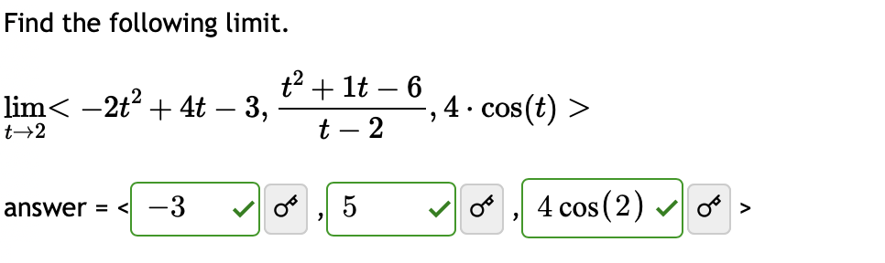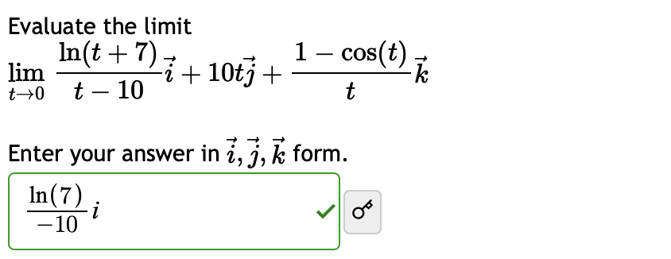

In case can not substitute -> Use L’Hospital’s Rule until it is possible

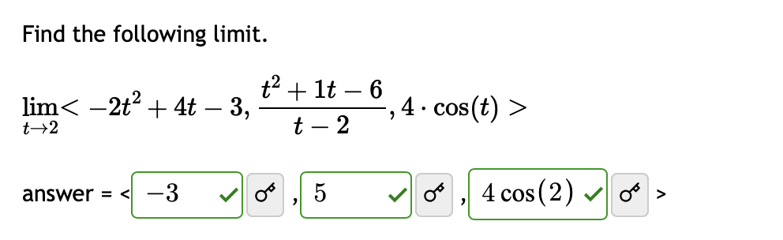

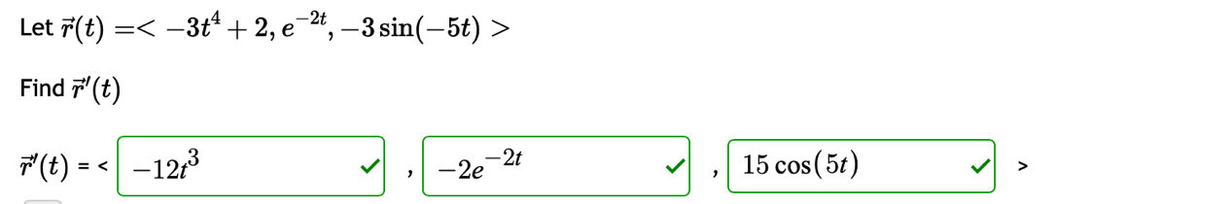

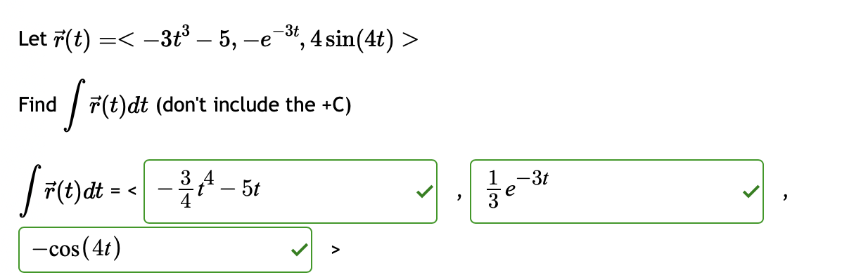

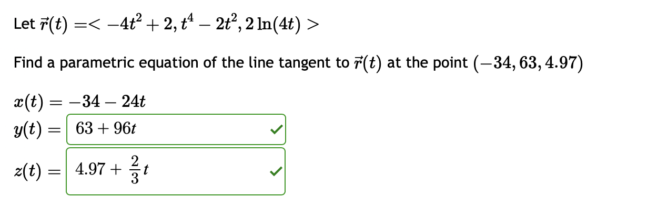

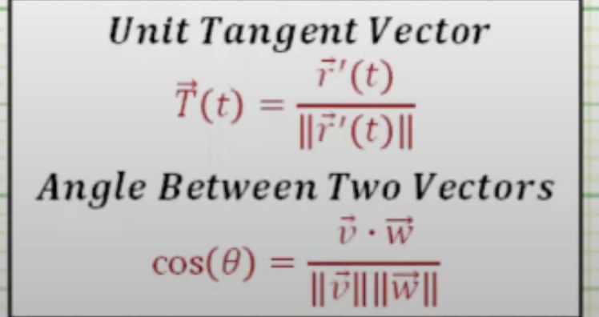

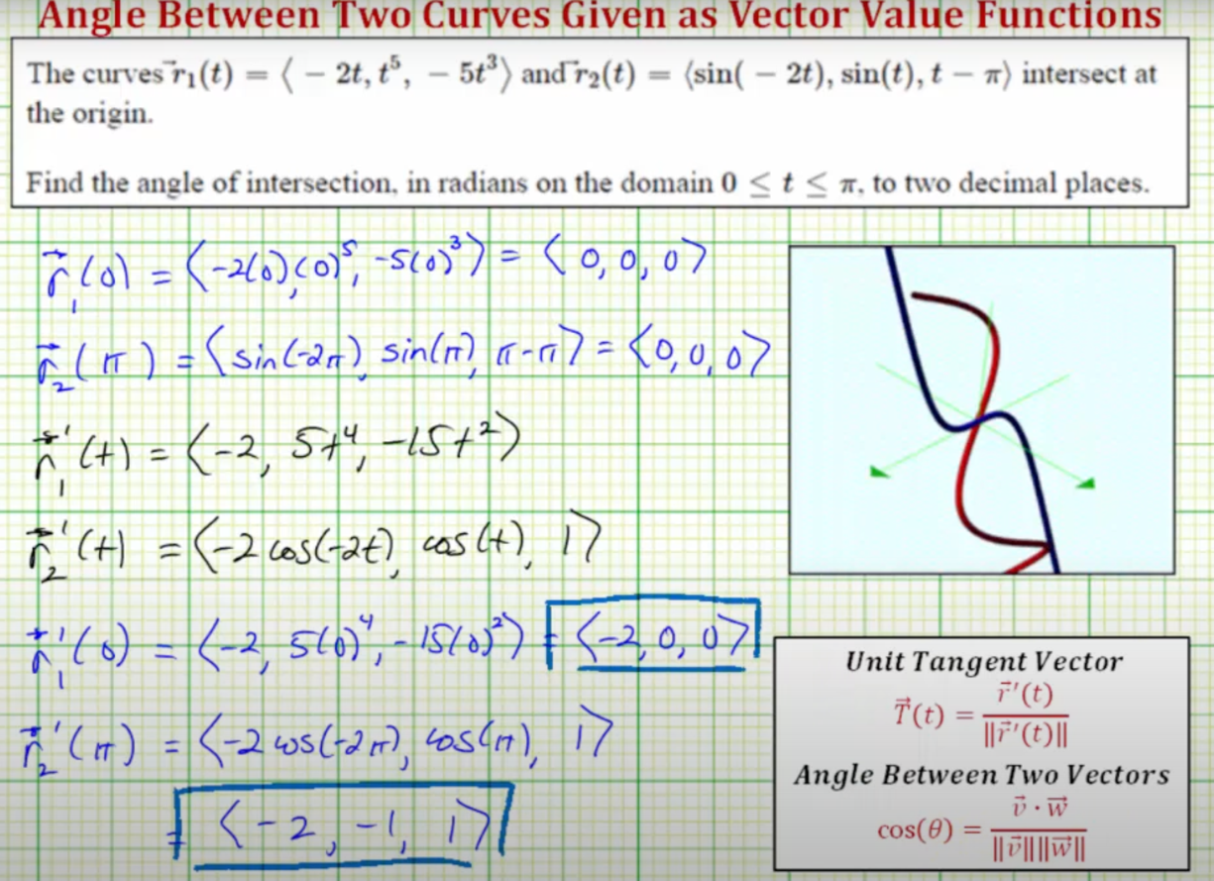

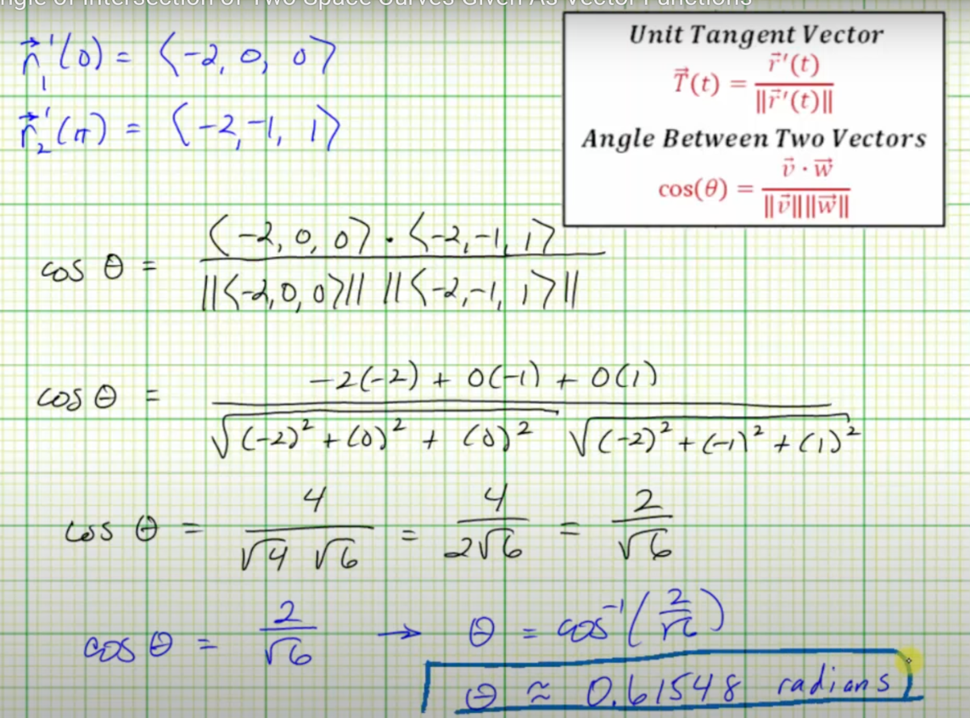\

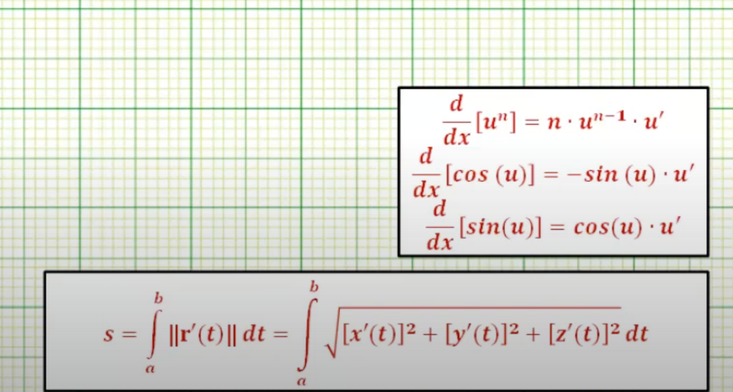

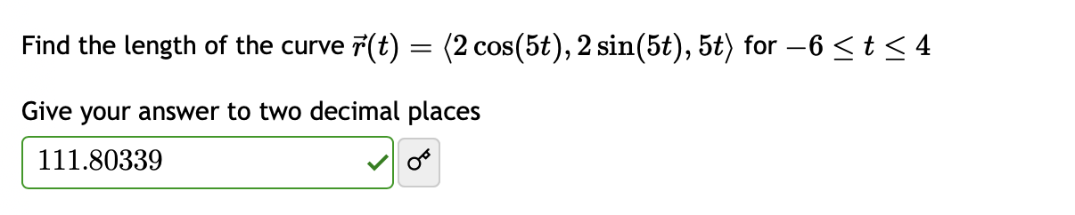

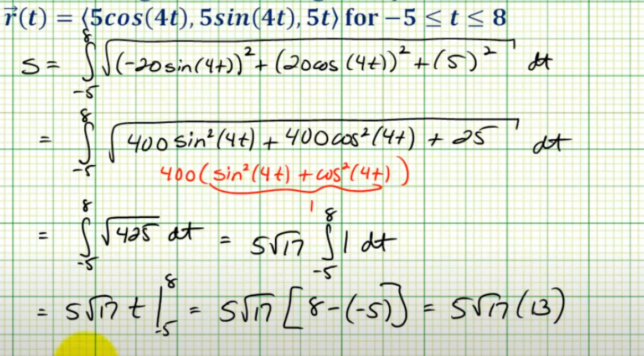

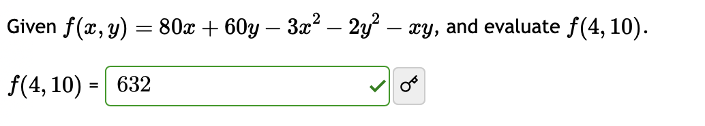

# Functions of Several Variables

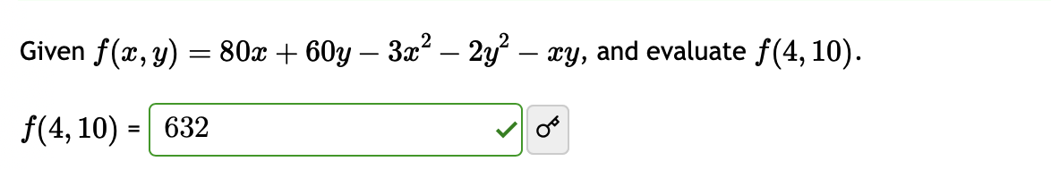

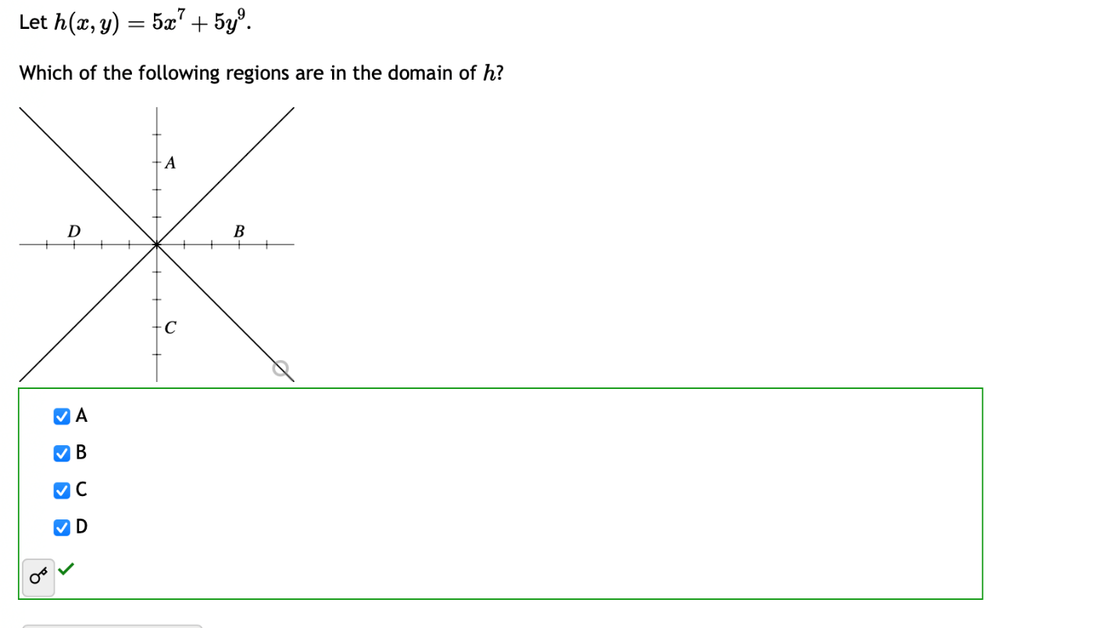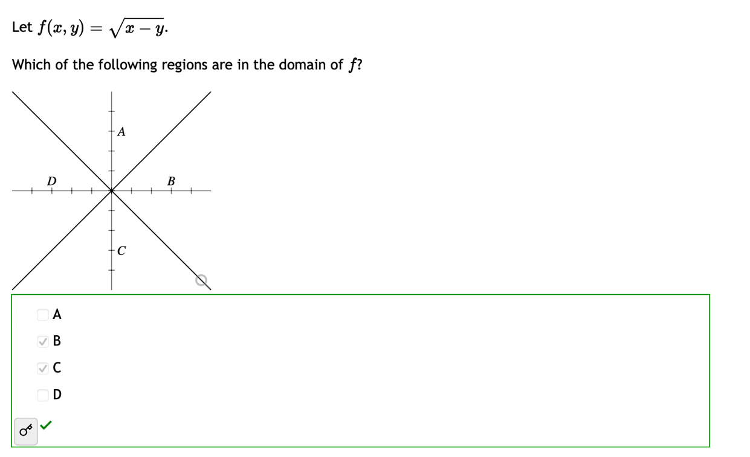



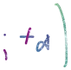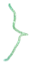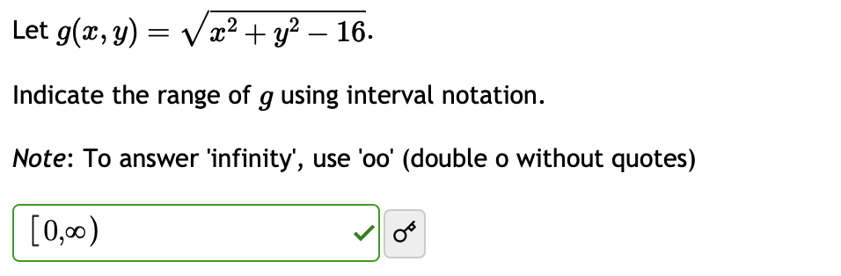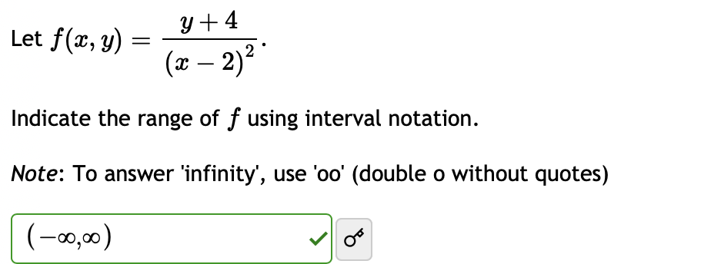



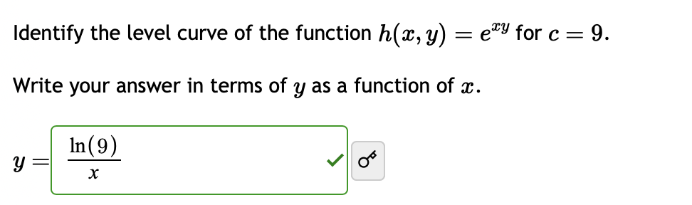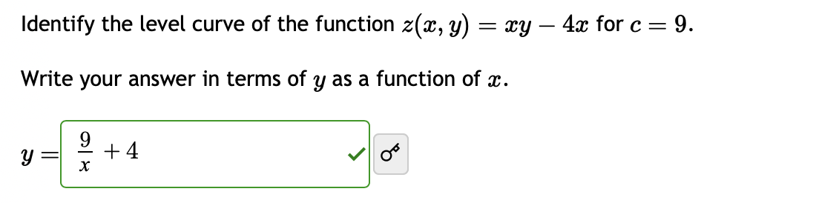

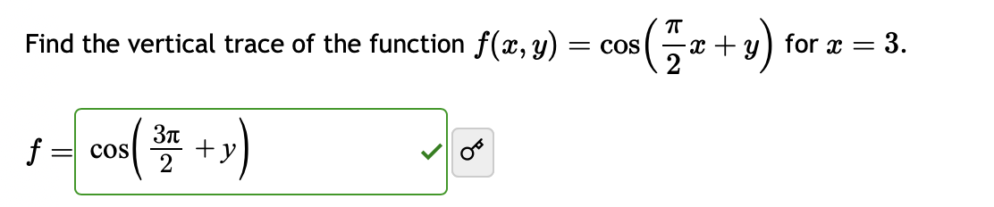

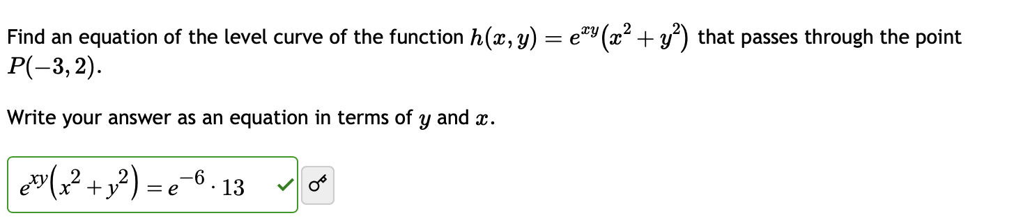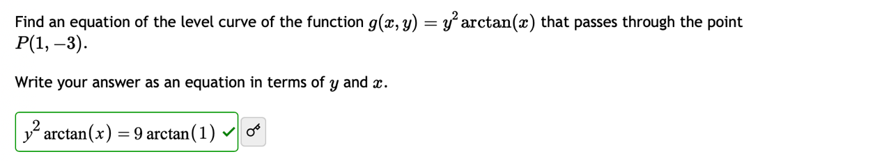

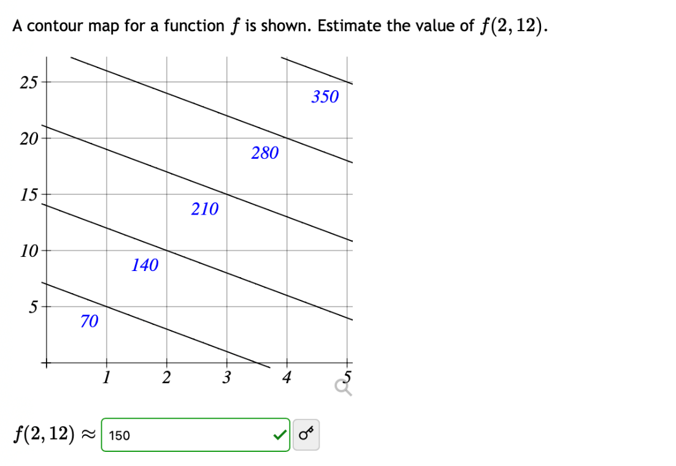

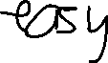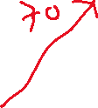

# Limits and Continuity

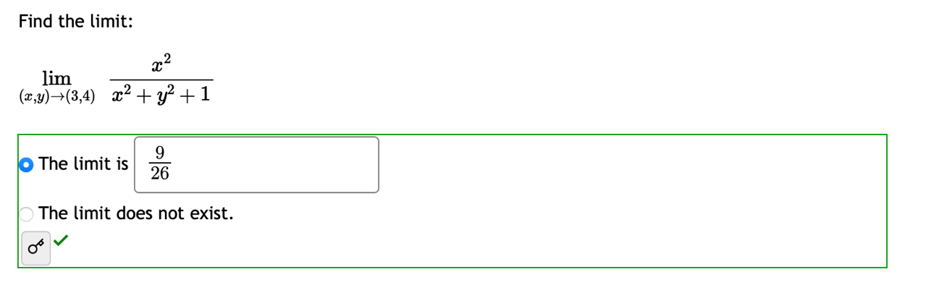

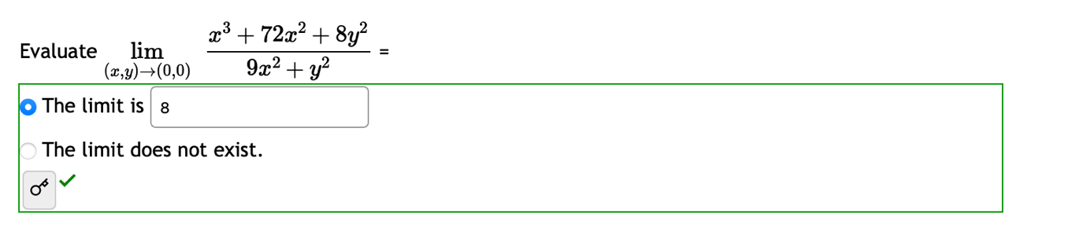

Use L’Hospital’Rule until it is possible to substitute (2 times x and y if dx >< dy or can not calculate it is not exist)



